API Header

📬 What is an API Header
# Source: AI Source: Provided by: [Data Path: Persons Table -> ID Column: 1, Name_En Column: Motasem Essam] -> From: [ChatGPT] on [1/19/2026]
An API Header is metadata sent along with an API request or response. Headers provide context, instructions, or additional information about the request or response without being part of the main data body. They help the server and client communicate context, authentication, format, and caching instructions.
👉 Think of headers as the envelope and labels of a package, giving instructions about the content without being the content itself.

🔑 Types of API Headers

1️⃣ Request Headers
# Source: AI Source: Provided by: [Data Path: Persons Table -> ID Column: 1, Name_En Column: Motasem Essam] -> From: [ChatGPT] on [1/19/2026]
Sent by the client to provide information about the request.
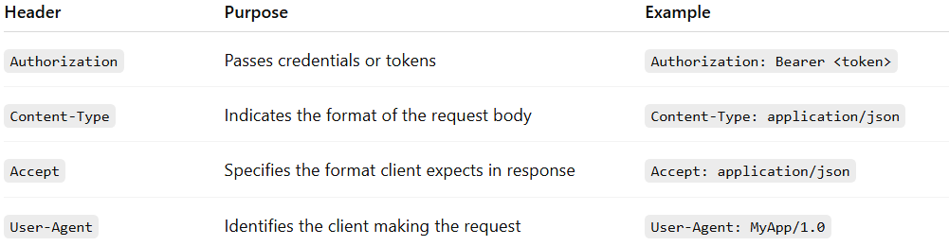
Header | Purpose | Example
Authorization | Passes credentials or tokens | Authorization: Bearer <token>
Content-Type | Indicates the format of the request body | Content-Type: application/json
Accept | Specifies the format client expects in response | Accept: application/json
User-Agent | Identifies the client making the request | User-Agent: MyApp/1.0

2️⃣ Response Headers
# Source: AI Source: Provided by: [Data Path: Persons Table -> ID Column: 1, Name_En Column: Motasem Essam] -> From: [ChatGPT] on [1/19/2026]
Sent by the server to provide information about the response.
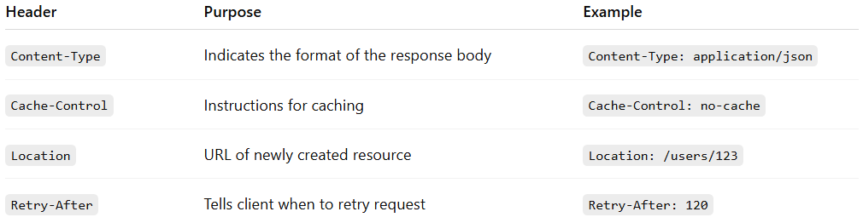
Header | Purpose | Example
Content-Type | Indicates the format of the response body | Content-Type: application/json
Cache-Control | Instructions for caching | Cache-Control: no-cache
Location | URL of newly created resource | Location: /users/123
Retry-After | Tells client when to retry request | Retry-After: 120

🧱 Example: Request & Response Headers

Client Request
# Source: AI Source: Provided by: [Data Path: Persons Table -> ID Column: 1, Name_En Column: Motasem Essam] -> From: [ChatGPT] on [1/19/2026]
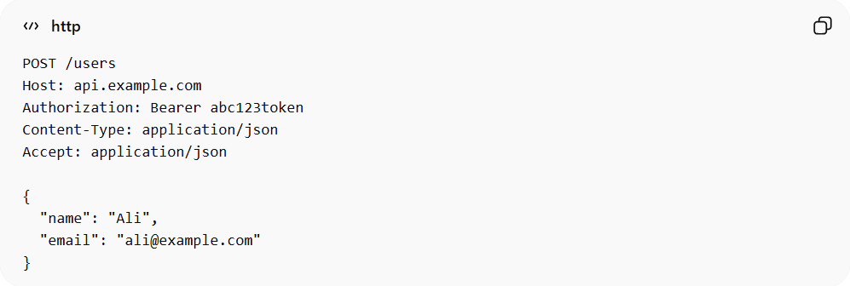
POST /users
Host: api.example.com
Authorization: Bearer abc123token
Content-Type: application/json
Accept: application/json

{
"name": "Ali",
"email": "ali@example.com"
}

Server Response
# Source: AI Source: Provided by: [Data Path: Persons Table -> ID Column: 1, Name_En Column: Motasem Essam] -> From: [ChatGPT] on [1/19/2026]
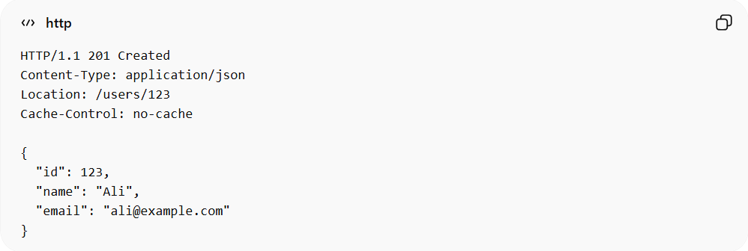
HTTP/1.1 201 Created
Content-Type: application/json
Location: /users/123
Cache-Control: no-cache

{
"id": 123,
"name": "Ali",
"email": "ali@example.com"
}

✅ Best Practices
# Source: AI Source: Provided by: [Data Path: Persons Table -> ID Column: 1, Name_En Column: Motasem Essam] -> From: [ChatGPT] on [1/19/2026]
- Always set Content-Type correctly
- Use Authorization headers for secure APIs
- Keep headers consistent across endpoints
- Avoid putting sensitive information in headers unless necessary

❌ Common Mistakes
# Source: AI Source: Provided by: [Data Path: Persons Table -> ID Column: 1, Name_En Column: Motasem Essam] -> From: [ChatGPT] on [1/19/2026]
- Forgetting to specify Content-Type
- Mixing request and response responsibilities
- Sending large data in headers (should be in body)

💡 Summary
# Source: AI Source: Provided by: [Data Path: Persons Table -> ID Column: 1, Name_En Column: Motasem Essam] -> From: [ChatGPT] on [1/19/2026]
API Headers provide context and metadata for requests and responses, enabling proper communication between client and server.

